# **Developed By**

* **Monojit Laha (** [**monojit.Laha@cognizant.com**](mailto:monojit.Laha@cognizant.com) **)**
* **Swadhin Mukherjee (** [**swadhin.mukherjee@cognizant.com**](mailto:swadhin.mukherjee@cognizant.com) **)**

# **Project Diagram**

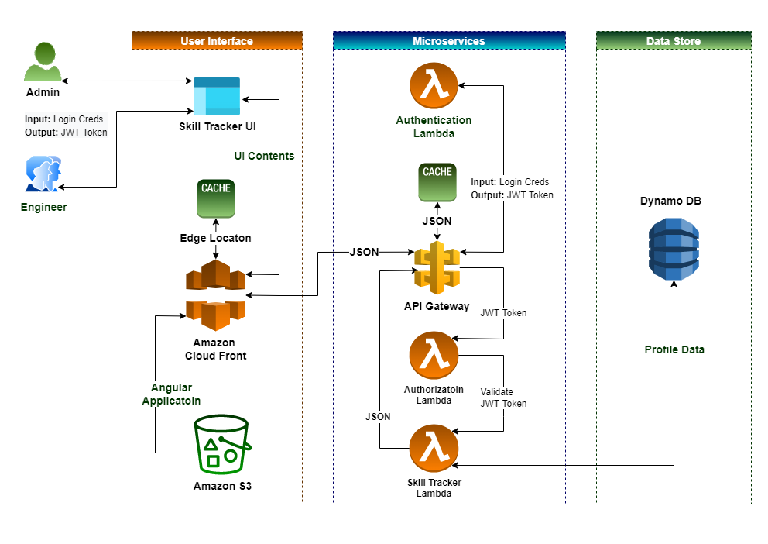

# **Git Repos**

|  |  |
| --- | --- |
| **Git Repo Name** | **Git Repo Link** |
| **Authentication Lambda** | <https://github.com/monojitlaha/skill-tracker-authentication-lambda.git> |
| **Authorization Lambda** | <https://github.com/monojitlaha/skill-tracker-lambda-authorizer.git> |
| **Skill Tracker Lambda** | <https://github.com/monojitlaha/skill-tracker-lambda.git> |
| **Angular UI** | <https://github.com/monojitlaha/skill-tracker-app.git> |